Question 1 +2:
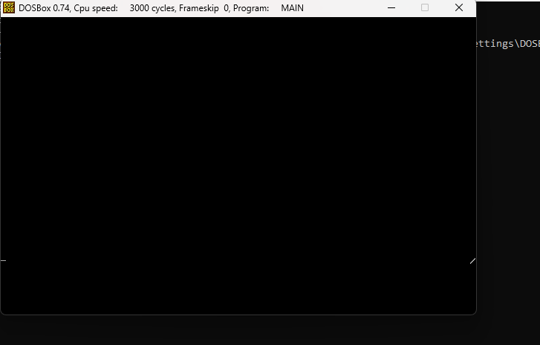
[org 0x0100]
jmp start

taskstates:
dw 0, 0, 0, 0, 0
dw 0, 0, 0, 0, 0
dw 0, 0, 0, 0, 0
dw 0, 0, 0, 0, 0
dw 0, 0, 0, 0, 0

current: db 0
chars: db '\|/-'

taskone:
mov al, [chars+bx]
mov [es:0], al
inc bx
and bx, 3
jmp taskone

tasktwo:
mov al, [chars+bx]
mov [es:158], al
inc bx
and bx, 3
jmp tasktwo

taskThree:
mov al, [chars+bx]
mov [es:20*160], al
inc bx
and bx, 3
jmp taskThree

taskfour:
mov al, [chars+bx]
mov [es:20*160+158], al
inc bx
and bx, 3
jmp taskfour

timer:
push ax
push bx
mov bl, [cs:current] ; read index of current task
mov ax, 10 ; space used by one task
mul bl ; multiply to get start of task
mov bx, ax ; load start of task in bx
pop ax ; read original value of bx
mov [cs:taskstates+bx+2], ax ; space for current task
pop ax ; read original value of ax
mov [cs:taskstates+bx+0], ax ; space for current task
pop ax ; read original value of ip
mov [cs:taskstates+bx+4], ax ; space for current task
pop ax ; read original value of cs
mov [cs:taskstates+bx+6], ax ; space for current task
pop ax ; read original value of flags
mov [cs:taskstates+bx+8], ax ; space for current task
inc byte [cs:current] ; update current task index
cmp byte [cs:current], 5 ; is task index out of range
jne skipreset ; no, proceed
mov byte [cs:current], 0 ; yes, reset to task 0

skipreset:
mov bl, [cs:current] ; read index of current task
mov ax, 10 ; space used by one task
mul bl ; multiply to get start of task
mov bx, ax ; load start of task in bx

mov al, 0x20
out 0x20, al
push word [cs:taskstates+bx+8]
push word [cs:taskstates+bx+6]
push word [cs:taskstates+bx+4]
mov ax, [cs:taskstates+bx+0]
mov bx, [cs:taskstates+bx+2]
iret

clrscr:
mov ax,0xb800
push ax
pop es
mov ax,0x0720
mov cx,4000
mov di,0
rep stosw
ret

start:
call clrscr
mov word [taskstates+10+4], taskone ; initialize ip
mov [taskstates+10+6], cs ; initialize cs
mov word [taskstates+10+8], 0x0200 ; initialize flags

mov word [taskstates+20+4], tasktwo ; initialize ip
mov [taskstates+20+6], cs ; initialize cs
mov word [taskstates+20+8], 0x0200 ; initialize flags

mov word [taskstates+30+4], taskThree ; initialize ip
mov [taskstates+30+6], cs ; initialize cs
mov word [taskstates+30+8], 0x0200 ; initialize flags

mov word [taskstates+40+4], taskfour ; initialize ip
mov [taskstates+40+6], cs ; initialize cs
mov word [taskstates+40+8], 0x0200 ; initialize flags

mov word [current], 0 ; set current task index
xor ax, ax
mov es, ax ; point es to IVT base
cli
mov word [es:8*4], timer
mov [es:8*4+2], cs ; hook timer interrupt
mov ax, 0xb800
mov es, ax ; point es to video base
xor bx, bx ; initialize bx for tasks
sti
jmp $ ; infinite loop

